January 10,2017
Sabbia Beach Luxury Condominiums

"Quite impressed with the views that you were able to create which now affords us the

luxury of being able to impress our prospective Buyers of luxury oceanfront

condominiums. Sales have definite improved since that

time. Thank you very much."

J.Falso

January 22, 2017
Florida Powerboat Club (President)

Joe is very professional...and focused on his task. Seems to have excellent command

of his drone craft, and is very safe in the

way he operates. On time for assignments and quick delivery of end product! S

Andrew B.
July 11, 2017

amazing! the professionalism, the customer service and the quality of their work far

exceeds all the other companies i have used. Ill never use anyone again.

Feel free to email me at delamaker5@aol.com to validate the quality of their work!

dealmaker5@aol.com

Anne K.
July 11, 2017

While in the process of searching for a Real Estate Agent to help sell my home I ran

across an Aerial view as well as a walk through video Video that was produced by

Skyview Productions. At that moment I felt this is

what I needed to showcase my home in a professional and detailed manner. I

contacted Mr. Kotrady who promptly responded in scheduling an appointment. We sat

down and he was able to provide me with what he felt

would be the best time of day that best highlighted my home and property. As a result

of his expertise and professionalism I received multiple offers and am happy to report

my home was sold within three weeks. I

would highly recommend Skyview Productions to anyone selling their home.

Brent B.
July 10, 2017

I was looking to compile a modern, state of the art and creative marketing video to

illustrate what we do and who we are. I had great expectations and knew it would be

very difficult and hard to find a company and

person to provide what I was looking for. I was referred to Skyview from a business

who used Mr. Kotrady and to give him a call. Wow! I was very impressed and very

excited to get our project started. From the moment

we met and the final product put together was beyond what I ever dreamed about.

Thank You Skyview for going over and beyond and doing whatever it took to get me to

say WOW! and become Speechless! I look

forward to sharing my experience with others are very thankful for your

professionalism, creativity and talent!

Bruce D.
July 10, 2017

Awesome all around. Great finished product, delivered with ease, and on budget.

Holly K.
July 10, 2017
We were very pleased with the aerial video that Joey at Skyview created for us. It

came out amazing! We look forward to using him again in the future.

Susan T.
July 10, 2017

Working with Joe and Skyview Productions was a joy. He takes pride in his work,

ensuring the end result meets the objectives of the client. I worked with him on two

different jobs, photographing my new listings which

came out beautifully, I've already received many compliments on them! Would

definitely recommend Skyview Productions!

Jason B.
July 10, 2017

The videos from Skyview Productions were way above what I expected. It's amazing

how something so small can create such beautiful images of my property. Definitely

helps with the sale of my house. A+++

July 9, 2017

(Anonymous Review)

Joe was a pleasure to work with. I would recommend him for any real estate

photography project you may have. I will definitely be using him again in the future.

Joe J.
March 8, 2017

I reached out to Skyview Productions after seeing there advertisement on social media

on how drones would be a useful tool in my industry of Private Investigations. Being a

business owner myself I know sometimes

you need the right tool to get the job done . iIf there was a tool out there that can save

me time and money and most importantly benefit the work I do I needed to see this for

myself. Just a few weeks after seeing Skyview's advertisement I put Joe and his

company to the test. With a recent troubled investigation I had with a Target that

burned 2 of my investigators hit a dead end. After discovering that the gated

community that are Target resided in was being tipped off to unknown vehicles trying

to gain access into the community our investigation efforts literally became blind. After

meeting with Joe to discuss how to get the results I needed I

was pleased to have learned that Joe is also a licensed private investigator. Now

feeling more comfortable and seeing how Joe conducted himself and came across as

very organized and professional I handed him the

rains. Being that the Targets home was located off of Florida intercoastal waterway's

Joe once again impressed me with how he planned out our surveillance day mission.

Taking it one step further Joe arrived in the area on his personal boat and directed my

investigator to establish a discreet surveillance position at the nearest intersection and

only way out of the neighborhood. Joe deployed his drone craft from his vessel and

hovered

over the waterway and was capable of zooming in his drone camera on the targets

home. Not much long after Joe's assistant radioed my investigator when the target

departed that Saturday morning. My investigator was able to maintain his mobile

surveillance efforts that day simply because he left his home with no suspicions nor

being alerted by the guards. I have since then referred Joe to other investigative

colleagues of mine and look forward to using him again in the future to come.

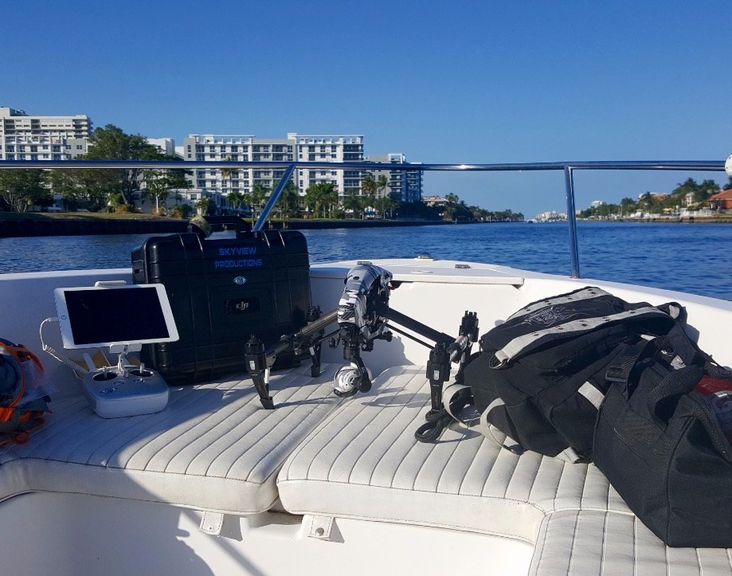

Maria K.
March 22 2017

My husband and I are looking for a property in Lighthouse Point. We don’t live in the

vicinity, so Skyview Productions videos were an incredible resource. We were able to

see the surrounding neighborhood, landscaping, inter-coastal access, dock facilities

and actual homes. We looked at 4 separate properties and we were able to narrow

down our search and pinpoint exactly which homes we should see in person. It has

saved us a tremendous amount of time. In fact, if there wasn’t a video of this nature to

view, we were less inclined to consider the property. We strongly feel that this is the

way everyone should showcase their homes If they don’t, those sellers are at a

disadvantage.

Fabrienne E.
March 28, 2017

I came across Skyview productions by word of mouth through a friend of mine who

was also renting out one of their properties and gave them a call. In an extremely timely

and professional manner I had amazing photographs of my property that are so

impressive I didn't even have to list with a Realtor. The quality of their work is

absolutely stellar and I highly recommend.
•


